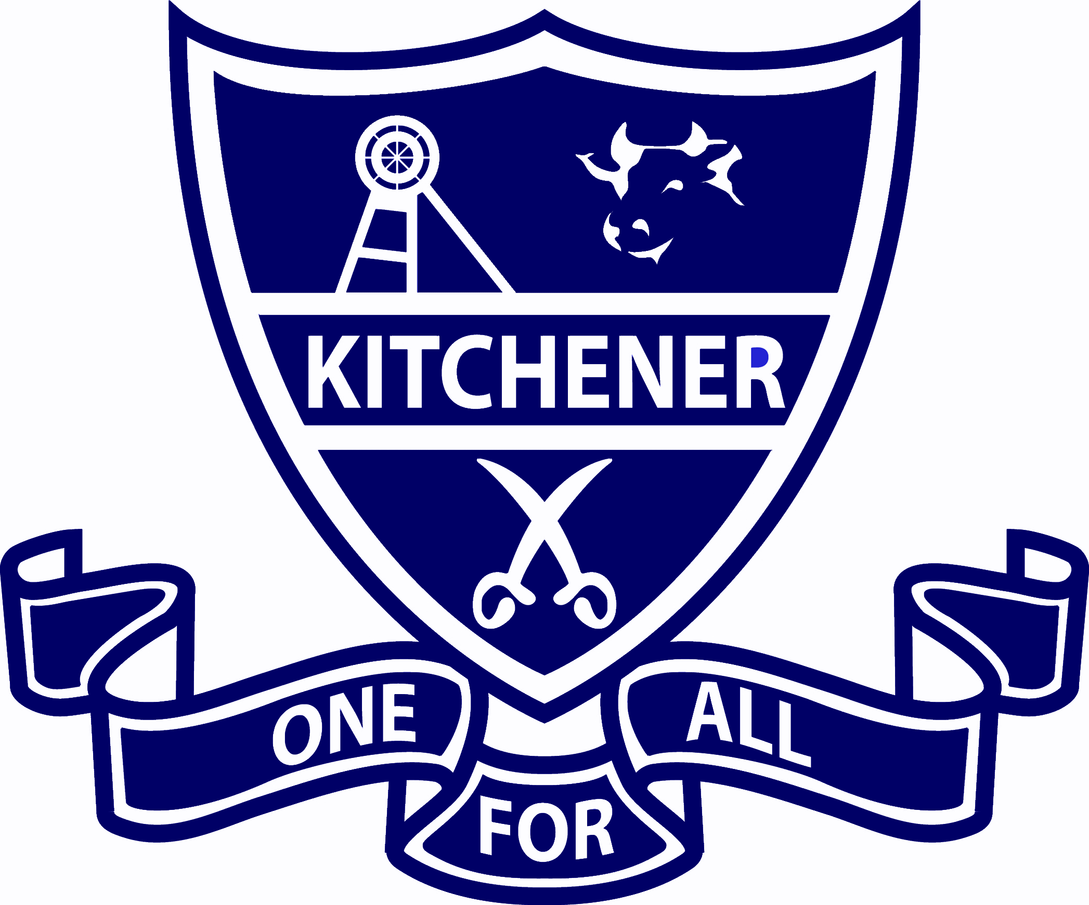
Special Religious Education and Special Education in Ethics Participation Letter

A feature of the public education system in NSW is the opportunity to provide time in class for education in ethics, faith and morality from a religious or non-religious perspective at the choice of parents.
A parent/carer may at any time notify the school in writing that they wish to change their decision. Students will continue the same arrangement as the previous year, unless a parent/carer has requested a change in writing.
For more information about Special Religious Education (SRE) and Special Education in Ethics (SEE), including the list of approved providers, please visit: https://education.nsw.gov.au/teaching-and-learning/curriculum/learning-across-the-curriculum/religion-and-ethics
If your preferred SRE or SEE option is not available please contact the approved provider. Students not attending SRE or SEE are given supervised alternative meaningful activities.
The following options are available at Kitchener Public School.
1. Combined Scriptures
During the time that SRE classes are being held, students not attending will be located in a separate space and will participate in meaningful activities focusing on well-being, values and friendships.
Please choose one.
SRE Options
□ Option 1: Combined Scriptures
OR
□ Please check this box if you do not wish for your child to attend SRE. Your child will participate in alternative meaningful activities.
After the initial enrolment, notification of changes to a child's enrolment in SRE should be given to the principal or office, in writing. (Email or written).

Student name: Year:
Signature of parent/carer: Date:

